Access Control Policy Document

PG Cybersecurity Program – Access Control Policy Document (NIST Standards)

Organization Name : PG Cybersecurity Program
Document Owner : Data Defenders (Project Group-8)

Approved By :
Role :
Signature :
Date :

Table of Contents
- Policy Overview
- Definitions & Abbreviations
- Access Control Policy
- Data Classification
- Incident Response (Healthcare & HIPAA Focus)
- Remote Work Access Control
- Policy Exception Management
- Legal and Regulatory Alignment
- Implementation Recommendations
- References & Citations
- Appendices

1. Policy Statement and Overview

1.1 Purpose
This policy establishes a formal, risk-based framework for controlling access to organizational information systems, applications, networks, and data. It ensures confidentiality, integrity, and availability (CIA) while complying with internationally recognized standards and healthcare regulations.
Primary Objectives
- Enforce least privilege and zero-trust principles
- Prevent unauthorized access and data breaches
- Ensure HIPAA-compliant handling of Protected Health Information (PHI)
- Support auditability and regulatory compliance
Validation:
Purpose aligns with NIST SP 800-53 Rev. 5 Access Control (AC) and Identification & Authentication (IA) control families.

1.2 Scope
This policy applies to:
- Employees, contractors, researchers, and third parties
- All on-premise, cloud, and hybrid systems
- Academic, administrative, and healthcare-related systems
- Remote access and mobile devices
- Out of Scope: National security systems (unless explicitly designated

1.3 Audience
- IT Administrators
- Cybersecurity & GRC Professionals
- Compliance Officers
- Academic Faculty and Auditors

1.4 Related Documents
- Information Security Policy
- Risk Management Policy
- Incident Response Plan
- Data Classification Standard

2. Definitions & Abbreviations
Term | Definition
Access Control | Mechanisms restricting system access to authorized users
Least Privilege | Granting minimum access required to perform duties
PHI | Protected Health Information (HIPAA)
MFA | Multi-Factor Authentication
RBAC | Role-Based Access Control
ABAC | Attribute-Based Access Control
Validation:
Definitions sourced from NIST SP 800-53 Appendix A (Glossary).

3. Policy Sections

3.1 Access Control Policy (General Requirements)

3.1.1 Authentication Requirements
- Unique user IDs for all users
- MFA mandatory for:
  - Remote access
  - Administrative privileges
  - Access to PHI systems
- Password policies aligned with NIST SP 800-63B
NIST Mapping: AC-2, IA-2, IA-5

3.1.2 Authorization Procedures
- Access granted based on:
  - Job role (RBAC)
  - Contextual attributes (ABAC for healthcare data)
- Privileged access requires:
  - Manager approval
  - Security team validation
NIST Mapping: AC-3, AC-6

3.1.3 Access Reviews
Aspect | Requirement
Review Frequency | Quarterly for privileged, PHI, and third-party access; annually for standard users
Trigger Events | Role change, termination, privilege escalation, security incident
Review Scope | User accounts, privileged accounts, service/system accounts, dormant accounts, remote access
Responsibility | Review and re-certification by System Owner and Line Manager
Remediation | Excess or unauthorized access removed within defined timelines; high-risk accounts disabled immediately
Evidence & Retention | Access review logs, approvals, and revocation records retained as per regulatory requirements

3.2 Data Classification
Classification Levels

Level | Description | Access Control
Public | Non-sensitive | Open
Internal | Organizational use | Authenticated users
Confidential | Business-critical | Role-based
Restricted, Highest sensitivity (PHI), PII | Regulated data | MFA + encryption
Control Requirements
- Classification applied at data creation
- Encryption for Confidential & Restricted data
- Logging and monitoring for PHI access
NIST Mapping: AC-16, MP-7, SC-12
HIPAA Mapping: §164.312(a), §164.306

3.3 Incident Response (Healthcare & HIPAA Focus)
Incident Categories
- Unauthorized access to PHI
- Credential compromise
- Insider misuse
Response Process
- Detection & alerting
- Containment
- Eradication
- Recovery
- Post-incident review
HIPAA Requirements
- Breach notification within 60 days
- Documentation of risk assessment
- Notification to affected individuals and regulators
NIST Mapping: IR-4, IR-5, IR-6
HIPAA Mapping: §164.308(a)(6)
Validation:
Fully addresses healthcare breach response obligations.

3.4 Remote Work Access Control
Requirements
- VPN with MFA
- Device compliance checks
- Split-tunneling disabled
- Session timeout enforcement
Prohibited
- Public/shared devices
- Unencrypted Wi-Fi access
NIST Mapping: AC-17, IA-2, CM-7

3.5 Policy Exception Management

3.5.1 Exception Process Steps
- Business justification submission
- Risk assessment
- Security review
- Executive approval
- Time-bound exception enforcement

3.5.2 Risk Assessment Criteria
Risk Factor | Description | Impact Level | Mitigation
Data Sensitivity | PHI or confidential data | High | Encryption
Exposure | Internet-facing access | High | MFA
Duration | Length of exception | Medium | Expiry date

3.5.3 Approval Workflow
Step | Responsible Role | Documentation Needed
Request | Business Owner | Exception form
Review | Security Team | Risk analysis
Approval | CISO/Delegate | Signed approval
Audit | Compliance | Exception log
Validation:
Aligned with NIST RA-3 and PM-9.

3.6 Legal and Regulatory Alignment
HIPAA Mapping Table
HIPAA Requirement | Policy Section
§164.312(a) Access Control | 5.1, 5.2
§164.308(a)(6) Incident Response | 5.3
§164.312(e) Transmission Security | 5.4

4. Implementation Guidelines
Access Control
- Deploy IAM with RBAC
- Enforce MFA organization-wide
- Automate provisioning/de-provisioning
Data Classification
- Define classification labels
- Integrate DLP tools
- Train staff annually
- Dpdp act
Incident Response
- Establish IR team
- Conduct tabletop exercises
- Maintain breach logs
Remote Work
- Harden VPN configurations
- Enforce endpoint security
- Monitor remote sessions
- BYOD
Validation:
Recommendations derived from NIST SP 800-53 and SP 800-61.

5. References & Citations
Primary Standards
- NIST SP 800-53 Rev. 5 – Security and Privacy Controls for Information Systems and Organizations
- NIST SP 800-61 Rev. 2 – Computer Security Incident Handling Guide
- NIST SP 800-63B – Digital Identity Guidelines
Healthcare & Legal
- HIPAA Security Rule (45 CFR Part 164)
- HHS Breach Notification Rule
GRC Frameworks
- ISO/IEC 27001:2022
- COBIT 2019

6. Access Control Maturity Framework

6.1 Purpose of the Maturity Framework
The Access Control Maturity Model provides a structured method to measure, assess, and continuously improve access control capabilities over time. It supports governance oversight, audit readiness, and strategic security planning.
This model is aligned with:
- NIST Cybersecurity Framework (CSF) – Identify & Protect
- NIST SP 800-53 Rev. 5 (AC, IA, RA, PM families)
- COBIT 2019 Capability Maturity Concepts
- ISO/IEC 27001 Continuous Improvement (PDCA)

6.2 Access Control Maturity Levels
Level | Maturity Stage | Characteristics | Risk Posture
Level 0 | Non-Existent | No formal access controls, shared credentials | Critical
Level 1 | Initial / Ad-Hoc | Manual user creation, no reviews | Very High
Level 2 | Repeatable | Basic RBAC, documented procedures | High
Level 3 | Defined | Formal IAM, MFA, periodic reviews | Moderate
Level 4 | Managed | Risk-based access, logging & monitoring | Low
Level 5 | Optimized | Zero Trust, continuous verification, automation | Minimal

6.3 Maturity Dimensions
- Governance & Policy
Defined access control policies with management oversight and regulatory alignment
- Technology & Controls
Centralized IAM with strong authentication and privileged access controls
- Processes
Joiner–Mover–Leaver (JML) workflows and formal exception management
- Monitoring & Assurance
Continuous monitoring and automated access reviews

6.4 Maturity Assessment Matrix
Control Area | Level 1 | Level 2 | Level 3
Authentication | Password-only | MFA enforced | Risk-adaptive MFA
Authorization | Static roles | RBAC + approvals | ABAC + Zero Trust
Access Reviews | None | Quarterly | Continuous
Privileged Access | Shared admin | PAM | Just-in-Time (JIT)
Remote Access | VPN only | VPN + MFA | ZTNA

6.5 Target Maturity Recommendation
- Academic & Healthcare Systems: Level 4 (Managed)
- Research & PHI Systems: Level 5 (Optimized)
Validation:
Model aligns with NIST SP 800-53 PM-9 (Risk Management Strategy) and RA-3 (Risk Assessment).

7. Mapping of Access Control Policy to ISO/IEC 27001:2022 Annex A

7.1 Purpose
This section demonstrates cross-framework alignment, enabling organizations to use this policy for ISO 27001 certification, audits, and gap assessments.
ISO/IEC 27001:2022 Annex A consolidates access control under organizational, people, physical, and technological controls.

7.2 ISO 27001 Annex A Control Mapping Table
ISO 27001:2022 Annex A Control | Control Description | Policy Section(s)
A.5.15 | Access Control | 5.1, 5.5
A.5.16 | Identity Management | 5.1.1
A.5.17 | Authentication Information | 5.1.1
A.5.18 | Access Rights | 5.1.2, 5.1.3
A.8.2 | Privileged Access Rights | 5.1.2
A.8.3 | Information Access Restriction | 5.2
A.8.5 | Secure Authentication | 5.1.1
A.8.9 | Configuration Management | 5.4
A.8.15 | Logging and Monitoring | 5.1.3, 5.3
A.5.29 | Information Security During Disruption | 5.3

7.3 NIST to ISO Crosswalk Summary
NIST SP 800-53 Control | ISO 27001 Annex A
AC-2 (Account Management) | A.5.16, A.5.18
AC-6 (Least Privilege) | A.8.2
IA-2 (Identification & Authentication) | A.5.17
IR-4 (Incident Handling) | A.5.29
RA-3 (Risk Assessment) | A.5.4
PM-9 (Risk Strategy) | A.5.1

7.4 Audit & Certification Benefits
- Enables single-policy, multi-framework compliance
- Reduces audit fatigue
- Supports ISO 27001 Statement of Applicability (SoA)
- Demonstrates governance maturity to regulators and faculty evaluators
Validation:
Mapping follows ISO/IEC 27001:2022 Annex A structure and NIST control intent equivalence.

8. Zero Trust Architecture (ZTA) Overlay for Access Control

8.1 Zero Trust Principles
This policy adopts Zero Trust as a strategic overlay, consistent with:
- “Never trust, always verify”
- Continuous authentication and authorization
- Explicit risk-based access decisions
Zero Trust is treated as an architecture and operating model, not a product.

8.2 Zero Trust Pillars Applied to This Policy
Zero Trust Pillar | Policy Integration
Identity | Strong IAM, MFA (5.1.1)
Devices | Device posture checks (5.4)
Network | VPN, ZTNA concepts (5.4)
Applications | Role- and attribute-based access (5.1.2)
Data | Classification & encryption (5.2)
Visibility | Logging & monitoring (5.1.3, 5.3)

8.3 Zero Trust Control Overlay Matrix
Traditional Control | Zero Trust Enhancement
VPN access | Context-aware ZTNA
Static RBAC | Dynamic ABAC
Periodic access review | Continuous authorization
Perimeter security | Identity-centric security
Trust after login | Trust evaluated every request

8.4 Zero Trust Access Decision Flow
- User identity verified (MFA)
- Device posture evaluated
- Risk context assessed (location, behavior)
- Least-privilege access granted
- Continuous monitoring enforced
- Access revoked upon risk change

8.5 Zero Trust Mapping to Policy Sections
Zero Trust Concept | Policy Section
Continuous Verification | 5.1.3
Least Privilege | 5.1.2
Micro-Segmentation | 5.4
Adaptive Authentication | 5.1.1
Breach Assumption | 5.3

8.6 Maturity Alignment
Zero Trust implementation aligns with:
- Maturity Level 4 (Managed) → Risk-based enforcement
- Maturity Level 5 (Optimized) → Fully adaptive Zero Trust
This ensures future readiness without breaking legacy environments.
Validation:
Zero Trust overlay is consistent with modern NIST Zero Trust principles and complements NIST SP 800-53 without conflict.

9. Policy Metrics & Key Performance Indicators (KPIs)

9.1 Purpose
Policy metrics and KPIs enable continuous measurement, governance oversight, and evidence-based improvement of access control effectiveness. Metrics support:
- Audit readiness
- Regulatory compliance (HIPAA, ISO)
- Risk management
- Executive reporting
Metrics are aligned with:
- NIST SP 800-53 (CA, AU, PM families)
- COBIT 2019 MEA domain
- ISO/IEC 27001 Clause 9 (Performance Evaluation)

9.2 Access Control KPI Framework
Identity & Authentication Metrics
KPI | Description | Target
MFA Coverage | % of users protected by MFA | ≥ 98%
Failed Login Rate | Failed logins per user/month | ≤ 5
Dormant Accounts | Accounts inactive > 90 days | 0
Privileged MFA Adoption | Admin accounts with MFA | 100%

Authorization & Least Privilege Metrics
KPI | Description | Target
Excess Privilege Rate | Users with unused permissions | ≤ 5%
Privileged Account Ratio | Admin vs total users | ≤ 3%
JML SLA Compliance | Provisioning/deprovisioning within SLA | ≥ 99%
Access Review Completion | Reviews completed on schedule | 100%

Monitoring & Incident Metrics
KPI | Description | Target
Mean Time to Detect (MTTD) | Access misuse detection time | < 24 hrs
Mean Time to Revoke Access | After termination/incident | < 4 hrs
Unauthorized Access Attempts | Monthly trend | Decreasing
PHI Access Anomalies | Flagged abnormal access | 100% reviewed

9.3 Governance Reporting
- Metrics reviewed quarterly by Security Governance Committee
- High-risk trends escalated to senior management
- Metrics retained for audit evidence (≥ 6 years for HIPAA)
Validation:
Supports COBIT MEA01, NIST CA-7, ISO 27001 Clause 9.

10. Cloud-Native Zero Trust Architecture (AWS Reference)

10.1 Purpose
This section extends the Zero Trust Architecture (ZTA) to cloud-native environments, ensuring secure access across hybrid and multi-cloud deployments.
Cloud Zero Trust aligns with:
- Identity-first access
- Continuous verification
- Policy-driven enforcement
- Native cloud security services

10.2 AWS Zero Trust Reference Alignment
Identity & Access
- IAM Roles (no long-lived credentials)
- MFA enforced for privileged roles
- Attribute-based access via tags
Network
- Private endpoints (no public exposure)
- Security Groups as micro-segmentation
- Zero Trust Network Access (ZTNA) via identity-aware proxies
Monitoring
- Centralized logging (CloudTrail, GuardDuty)
- Continuous access behavior analytics

AWS Mapping to Policy
Policy Control | AWS Native Capability
Least Privilege | IAM Roles & Policies
MFA Enforcement | IAM MFA
Privileged Access | Temporary role assumption
Logging | CloudTrail
Incident Detection | GuardDuty

11. Diagrams – Zero Trust & Access Control Maturity Model

11.1 Zero Trust Architecture Diagram (Conceptual)
Diagram Description
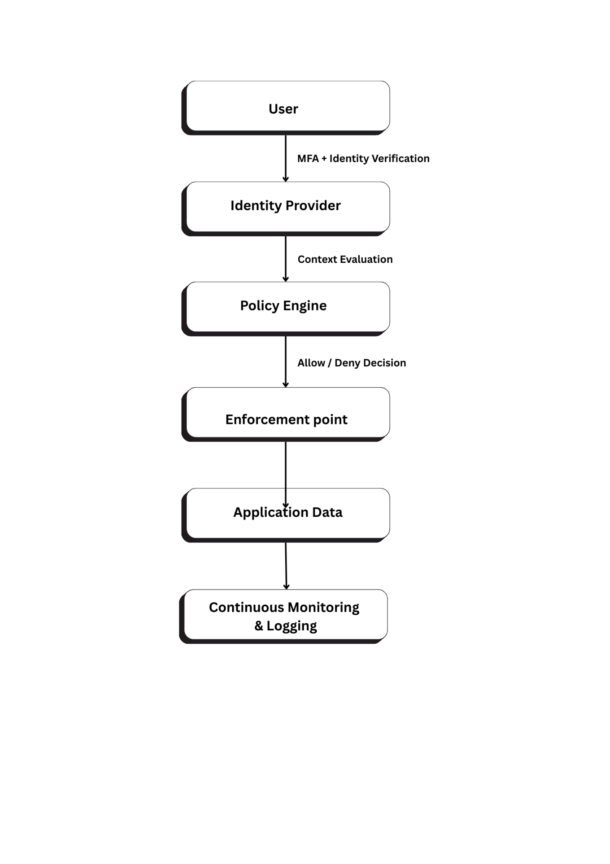
Key Elements
- Identity is the primary trust anchor
- Access decisions are dynamic and contextual
- Monitoring is continuous, not periodic
Policy Alignment: Sections 5.1, 5.3, 12

11.2 Access Control Maturity Model Diagram
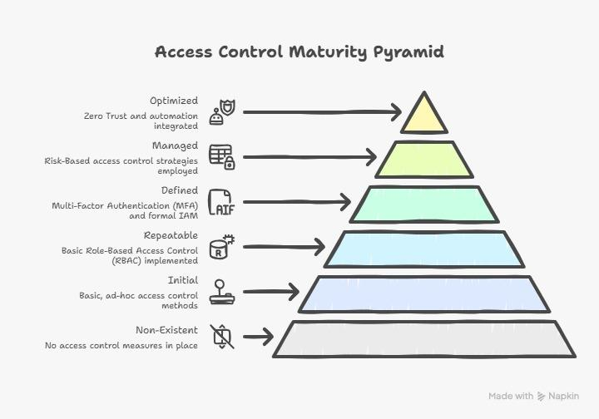
- Progression reflects reduced risk and increased assurance
- Zero Trust maturity aligns with Levels 4–5
- Healthcare and PHI systems must target ≥ Level 4
Policy Alignment: Section 9 (Maturity Model)

12. Policy Review and Maintenance
- Policy reviewed at least annually
- Review triggered by regulatory, system, or business changes
- Updates approved by the policy owner and governance authority
- All revisions documented through version control
This policy serves as the authoritative standard for access control within the organization and supports consistent, secure, and compliant access management practices.

